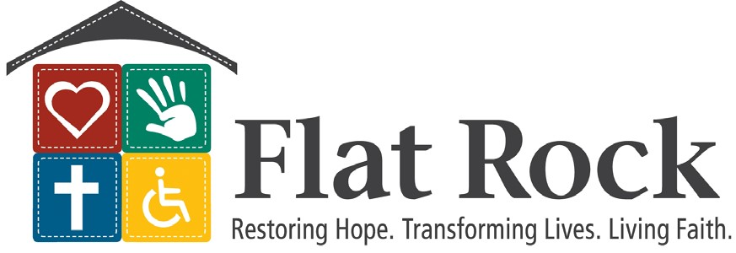
Rose M Darling’s Church Engagement Menu for 2025
All sermons/messages are updated with current news from Flat Rock!
MESSAGES:
- Restoring Hope and Transforming Lives through a Living Faith. Features inspiring true stories about individuals served by Flat Rock. PART II also available
- Angels Among Us: Updated! Stories and Scriptures about angels, their ministries, and living like an angel!
- Disability Awareness messages to enlighten, encourage, and engage:
Offering two messages:
Discovering and Overcoming Biases
Interactive disability awareness presentation
- The Best: The Beatitudes in Action: Ideal for special times of the year such as summertime, Thanksgiving, Easter, Christmas, etc.
- Many Hats: One Mission. Flat Rock at work
MUSIC PRESENTATIONS: Organ or Piano
- This is My Story: This is My Song: Stories and songs of famous composers and musicians with disabilities. Hymns, classical, and other music
- A Flat Rock Christmas: Music and stories celebrating Christmas
- An All-American Song Fest: features well-known songs of the States, hymns and anthems
- Organ/piano supply Ask me about filling-in when your pianist or organist is not available, or when you need someone.

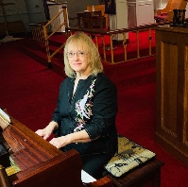
Contact:
Rose M Darling, Church Engagement Coordinator with Flat Rock Homes, Care Center & Community Services
E-mail: rdarling@flatrockhomes.org
Text/call 330-639-5378

Available for churches or groups of any denomination. All freewill donations go directly to support Flat Rock’s ministries to individuals with developmental and intellectual disabilities. Many references are available.

