Geoffrey Darling
Presents Mark’s Gospel
A fundraiser for Flat Rock Homes
Now booking for 2025
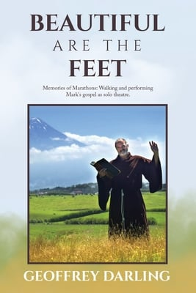
Part One: Geoffrey Darling performs several chapters of Mark’s Gospel as solo theatre.

Originally from New Zealand, Geoffrey this year celebrated 25 years of performing Mark’s Gospel with an account of his experiences, Beautiful Are the Feet
Part Two is an illustrated talk about his adventures, insights and experiences, notably a month-long 600-mile walk (18-25 miles per day for 33 consecutive days) covering New Zealand’s South Island, and performing Mark’s Gospel at every possible venue..

- Freewill donations will benefit Flat Rock Homes Care Center & Community Services.
- Beautiful Are The Feet will be on sale for $20 with $5 of that also going to Flat Rock Homes.

For more information: geoffrose05@yahoo.com/ 330 819 8109
www.flatrockhomes.org

